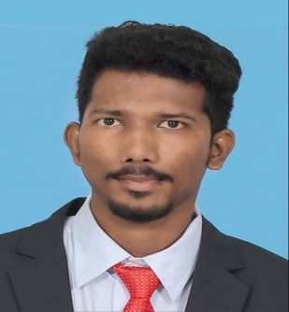**Rajesh Kumar S**

| Email Id: rajeshsakthiv@gmail.com|

| Location: Salem | Mobile: +91 8778122774 |

| LinkedIn: <https://www.linkedin.com/in/rajesh-kumar-s8b7002b1> |

--------------------------------------------------------------------------------------

*To secure a responsible career opportunity to fully utilize my training and skills, while making a significant contribution to the success of the company.*

*--------------------------------------------------------------------------------------*

**Education**

Professional : M.B.A - Finance & Marketing

*Sona School Of Management, 2018 - 2020*

*Salem Area, India*

Under Graduate : B.E - Electrical & Electronics Engineering - | First Class |

*Dhirajlal Gandhi College Of Technology, 2014 - 2018*

*Salem Area, India*

Class XII : Vedha Vikaas Hr.Sec.School | 2014 | 81% |

Class X : Sri Sarada Balamandir Boys Mat.Hr.Sec.School

|2012 | | 82 % |

**Professional Skills**

Strong Communication Skills

Strong Interpersonal Skills

Time Management and Project Management Skills

Teamwork and Collaboration

Positive Attitude and Strong Work Ethic

Adaptability and Multitasking

**Areas Of Expertise**

Customer Relationship Management (CRM)

Sales Forecasts

Inbound Marketing

Business Intelligence

Data Scientist

**Certificates & Accolades**

* Certified in ***Business English Certificate (Preliminary – Level)*** conducted by ***University Of Cambridge United Kingdom***.
* Certified in ***Business Intelligence and Data Visualization*** fundamentals (Mode: Online | Duration 14 weeks).
* Certified in ***Data Science*** completed via ***Internshala Learning & Training*** (Mode: Paid Online | Duration 2 months).
* Certified in ***Inbound Marketing*** completed via ***HubSpot Academy***.

**Work Experience/Internship**

**Sales/Marketing Executive Trainee**

*NJ India Invest, August 2019 - October 2019*

*Coimbatore Area, India*

As a Sales/Marketing Executive Trainee my major role was to

1. **Identifying new sales leads**
2. **Maintaining fruitful relationships with existing customers**
3. **Filling KYC forms prerequisites and inquiring customers.**

When it comes to generating leads, day-to-day duties typically include:

* Researching Banking Institutions and individuals online (especially via IRDA) to identify new leads.
* **Contacting potential clients** via **email or phone** to establish rapport and set up meetings.
* Preparing **PowerPoint presentations** and **sales displays.**
* **Follow-up, negotiating and renegotiating** via phone, email and in person.

**Languages Known**

Tamil : Expert/Native

English : Expert

**Declaration**

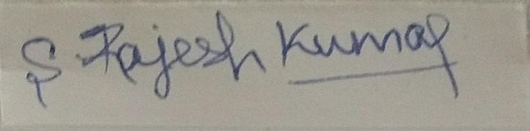I hereby declare that the above mentioned is correct up to my knowledge and I bear the responsibility for the correctness of the above mentioned.